**Clutchiness in the NBA:**

**Can Chef Curry take the heat or does he need to get out of the kitchen?**

By Schuyler Cross and Jimmy McMillian

Period 7

**Introduction**

If you’ve ever watched SportsCenter, ESPN News, or any other sports networking show, the announcers seem to always be throwing around the word “clutch”. In basketball, “clutch” is usually associated with players like Lebron James, Steph Curry, and Kevin Durant. These players are undoubtedly some of the best players in the league right now, but are they really clutch? This is what we are investigating.

Clutch, in sports, is defined as denoting or occurring in a critical situation in which the outcome of a game or competition is at stake. We agree that players can be clutch at times, but we are trying to determine which players exhibit clutchiness or are consistently clutch.

To determine which NBA players show clutchiness, we looked at the starting five of each team in the NBA. We compared their field goal percentage (FG%) on the season to their clutch field goal percentage (CFG%) of that same season. FG% were found on the basketball reference. We determined their CFG% by looking at the player’s shots taken to tie or take the lead in the last two minutes of each quarter. The number the made versus how many they took during the whole season was their final CFG% of the season.

**Who were the clutchiest? Who were the chokiest?**

We considered clutch to be an increase in percentage between FG% and CFG%, so if CFG% - FG% was positive, the player exhibited clutch playing. If the difference was negative, the player tended to choke. Although many players had clutch seasons, we consider players who have a positive difference for two years in a row (2015-16 and 2014-15) to show clutchiness. These players are:

* Marcus Smart, Boston Celtics
* Tony Allen, Memphis Grizzlies
* Eric Gordon, New Orleans Pelicans
* Kentavious Caldwell-Pope, Detroit Pistons
* C.J. McCollum, Portland Trail Blazers
* Michael Carter-Williams, Milwaukee Bucks
* Kent Bazemore, Atlanta Hawks
* Al Horford, Atlanta Hawks
* Harrison Barnes, Golden State Warriors
* Jordan Clarkson, Los Angeles Lakers
* Channing Frye, Orlando Magic
* Eric Bledsoe, Phoenix Suns
* Tyson Chandler, Phoenix Suns
* Rudy Gaye, Sacramento Kings

Players who were especially clutch (three years with positive differences) were:

* Wesley Johnson, Los Angeles Clippers
* Demarre Carroll, Toronto Raptors
* Anthony Davis, New Orleans Pelicans
* Thaddeus Young, Brooklyn Nets

These players were able to perform in tight situations. This however is not always the case. Players who perform below their usual norm in tight situations are said to choke. To separate the true chokers from players who perform slightly below average, we considered a decrease in 15% or greater in CFG% will qualify the player as a choker. This is the list of players whose average CFG% for the 2015-2016 and 2014-15 seasons are greater than or equal to 15%:

* Zaza Pachulia, Dallas Mavericks
* Bojan Bogdanovic, Brooklyn Nets
* Trevor Ariza, Houston Rockets
* Isaiah Canaan, Philadelphia 76’ers
* Jahlil Okafor, Philadelphia 76’ers
* Tyreke Evans, New Orleans Pelicans
* Kyle Lowry, Toronto Raptors
* Jonas Valanciunas, Toronto Raptors
* Tony Snell, Chicago Bulls
* Kevin Garnett, Minnesota Timberwolves
* Ersan Ilyasova, Detroit Pistons
* Kevin Durant, Oklahoma City Thunder
* George Hill, Indiana Pacers
* Trey Burke, Utah Jazz
* Rodney Hood, Utah Jazz
* Jeff Teague, Atlanta Hawks
* Andrew Bogut, Golden State Warriors
* Roy Hibbert, Los Angeles Lakers

Names that stand out on this this are Kevin Durant, Jahlil Okafor, and Kyle Lowry. They are players who are considered game leaders on ESPN. Other players who did not meet the 15% mark, but showed some levels of chokiness include Steph Curry, Klay Thompson, Russell Westbrook, Kevin Love, Derrick Rose, Carmelo Anthony, Kobe Bryant, Blake Griffin, John Wall and Dirk Nowitzki. These players are also considered game leaders.

**Now looking at the clutch players…**

Below is a graph of the players who were clutch in the 2014-2015 and 2015-2016 seasons.

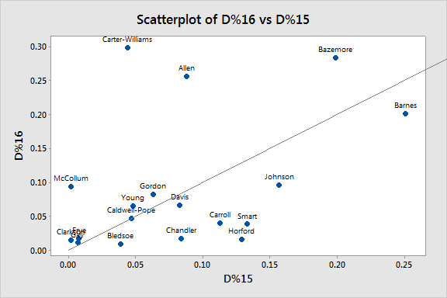

**Which players fall nearest to the Lott-Soler line (LSL)**

The line through the middle of the scatterplot is referred to as the Lott-Soler Line. With a slope of 1, its purpose is to act as a comparison. The closer to the line a player is, the more consistently that player is shooting. Players like Kentavious Cadwell-Pope and Rudy Gay, despite how more or less clutch they are, fall right on the line and are the most consistently clutch players over the 2014-2015 and 2015-2016 seasons. Jordan Clarkson, Channing Frye, Anthony Davis, Thaddeus Young, and Eric Bledsoe are a few other players that were consistent in *how clutch* they were.

**How did the clutch players near the LSL do in a third year?**

When adding the 2013-2014 to the mix...

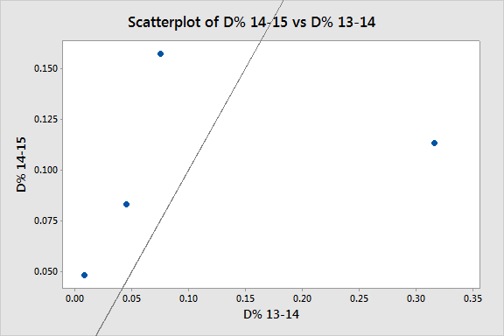

We see that there are just four players who display clutchiness: Thaddeus Young, Anthony Davis, DeMarre Carroll, and Wesley Johnson. These four players shot an average Clutch FG% of 9.266% better in clutch situations than they did normally. However their individual Clutch FG% fluctuated through the three coverage years, which an average range of 9.863%. Three of the four players are shooting guards, indicating that the easiest and most reliable shots in crunch time are those in the paint or close to the basket.

Most of the players under our coverage have at least one year where they fall under our definition of clutch. In fact, 33 of the 150 players displayed clutchiness in two of the three seasons of data.

Of the clutch players, there is really only one noticeable superstar: Anthony Davis. And NOT Steph Curry. Perhaps top tier players with “ice in their veins” and faces on billboards, don’t deserve all of the last minute opportunities. With time low, my bet is on the big man.